- Screenshot: record detail page for a connected org
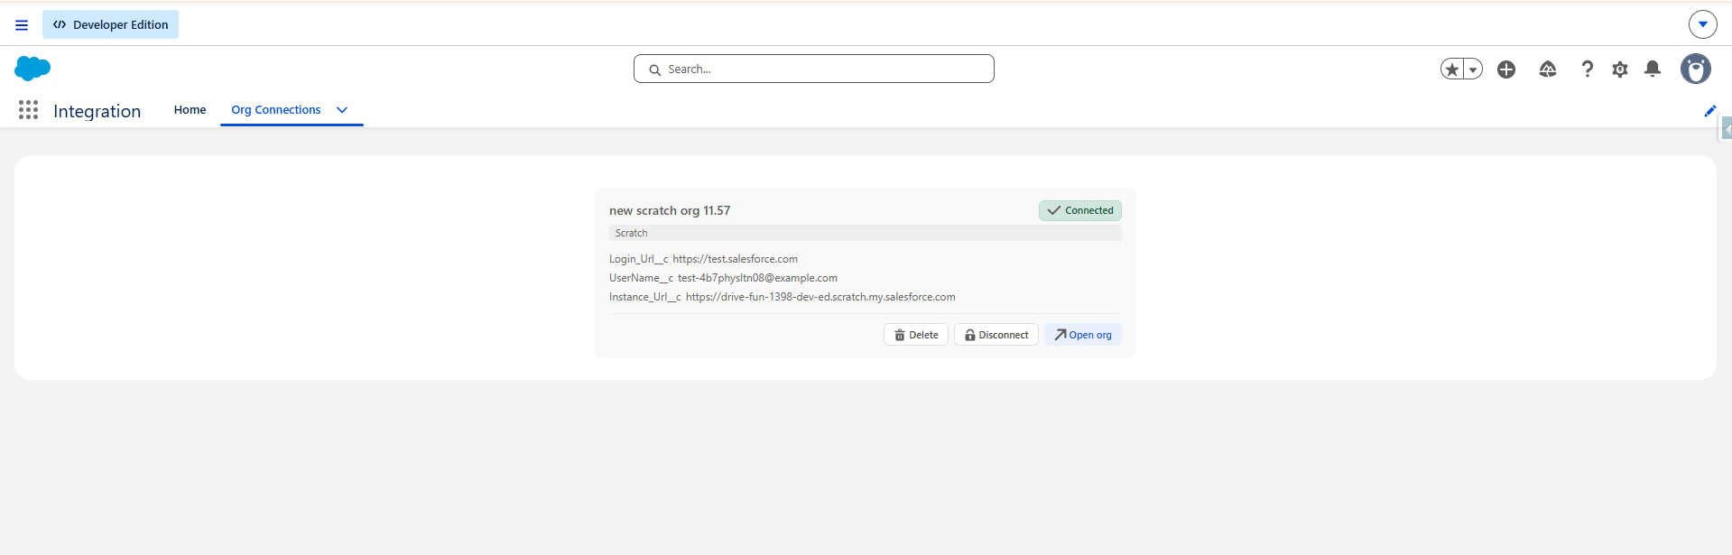

- Screenshot: success toast after linking
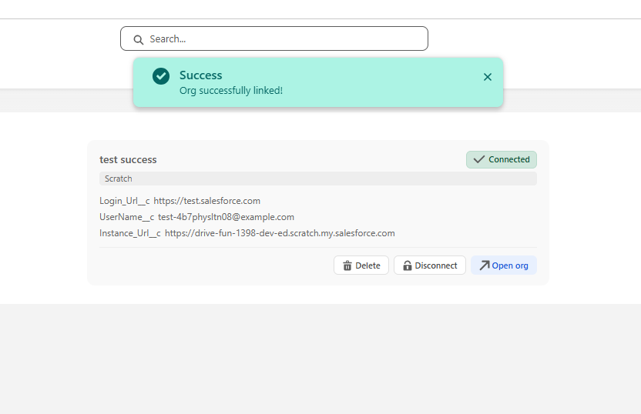

- Screenshot: error state after failed linking
